**Birthday Website**

**Code:**

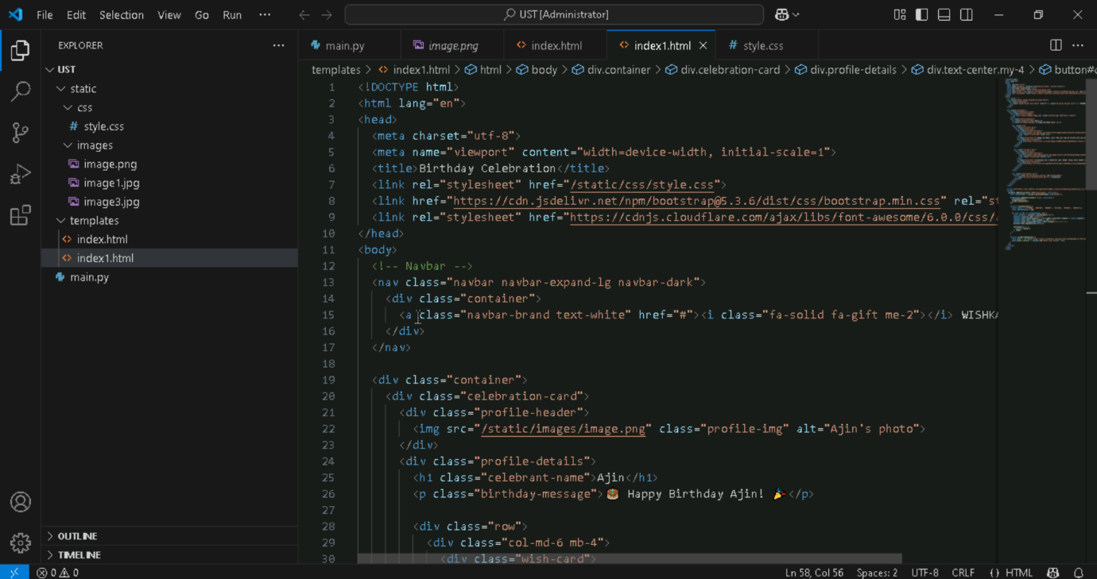

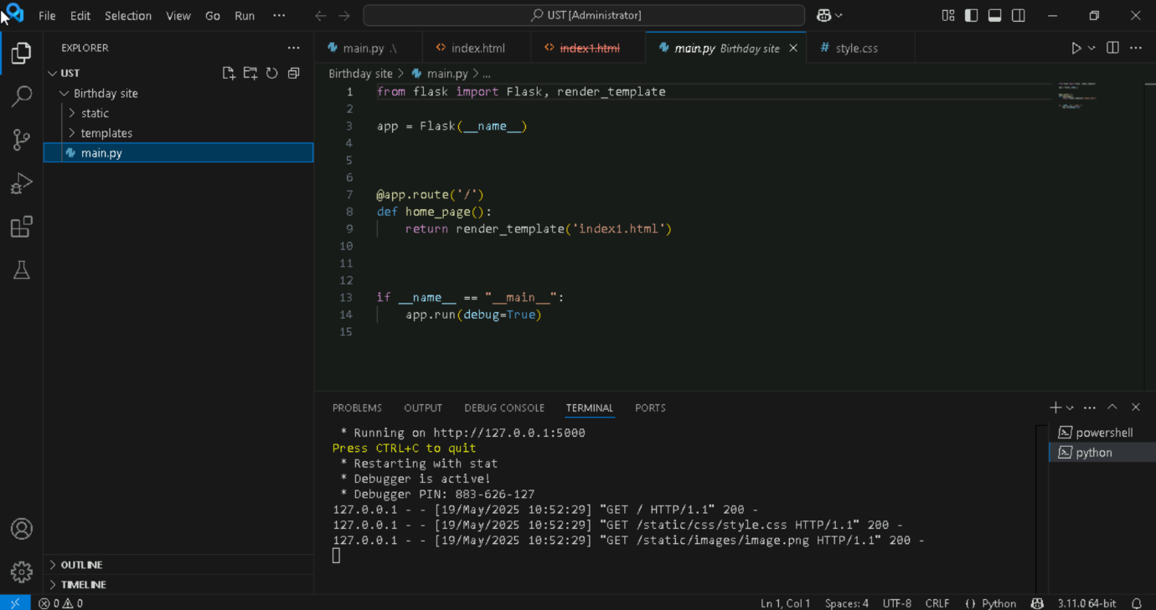

**User Interface:**

